**Lab 8: PID Controller in MATLAB/Simulink**

650:361 Introduction to Mechatronics

Team Members: Shivani Topiwala, Nancy Contreras, and Pamela Pajarillo

**Introduction**

We will be analyzing PID control, which is one of the most common feedback control for a dynamic system. We can simulate a closed loop step response of the dynamic system below.

$x{}_{1}^{'}= -0.1x{}_{1}+0.1x{}_{2}$

$x{}_{2}^{'}= -0.2x{}_{2}+0.1u$

$y= x{}_{1}$

$G(s)= \frac{0.01}{s^{2}+0.3s+0.02}$

$Y(s)= G(s)U(s)$

Where u is the input, y is the output, $x{}_{1}^{}$ and $x{}_{2}$ are the states of the system and G(s) is the the transfer function of the system.

**Task A: Closed-Loop Unit Step Response**

We will analyze the results of a closed loop controller given the equation

$C(s)= K{}_{p}+\frac{K{}_{i}}{s}+K{}_{d}s$ 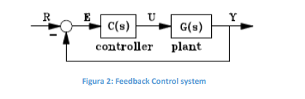

Figure 1: Closed-Loop Unit Step Response

We modified the model by changing the parameters on the PID controller block. We ran the simulations of the closed loop unit-step input response for different combinations of the PID gains listed below.

Figure 2: Different Control Action Parameters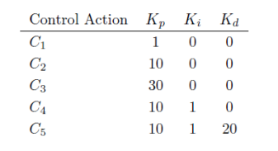

Figure 3: Simulink Model to Collect Output Data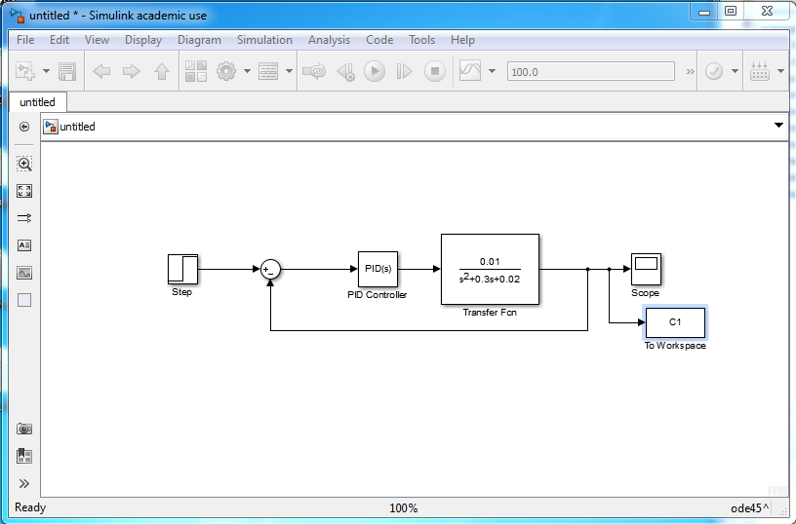

Figure 4: Unit Step Output Responses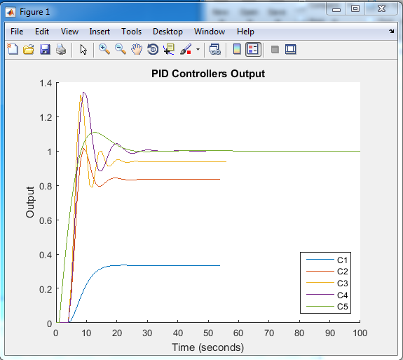

This is a plot of all the unit-step output (y(t) vs. t) responses of the system. There is a legend to distinguish which graph represents which output values.

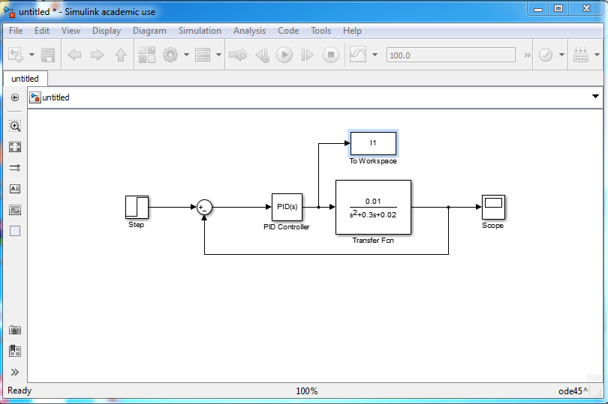

Figure 5: Simulink Model to Collect Input Data

Figure 6: Unit Step Input Responses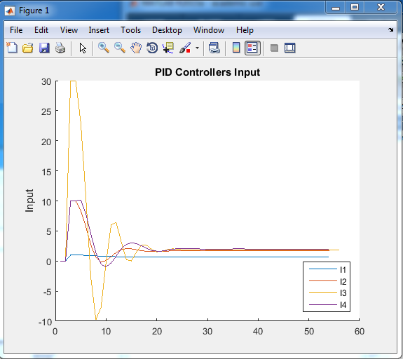

This is a plot of all the unit-step input (u(t) vs. t) responses of the system. There is a legend to distinguish which graph represents which input values.

Figure 7: Unit Step Input Response of 5th Control Action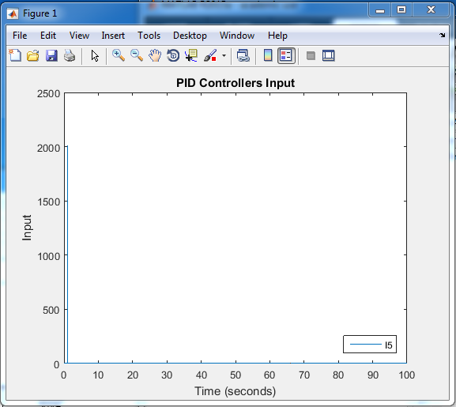

This is a plot of all the unit-step input (u(t) vs. t) responses of the system of the 5th control action since it is too large to put on the graph with the rest.

**Task B: Automatic PID Tuning**

By using **pidtune** or the graphical user interface using **pidtool**, we can change the parameters of the controller. The parameters were rise time less than 2 seconds, overshoot less than 5%, and steady state error $e{}_{ss}^{}=0.$

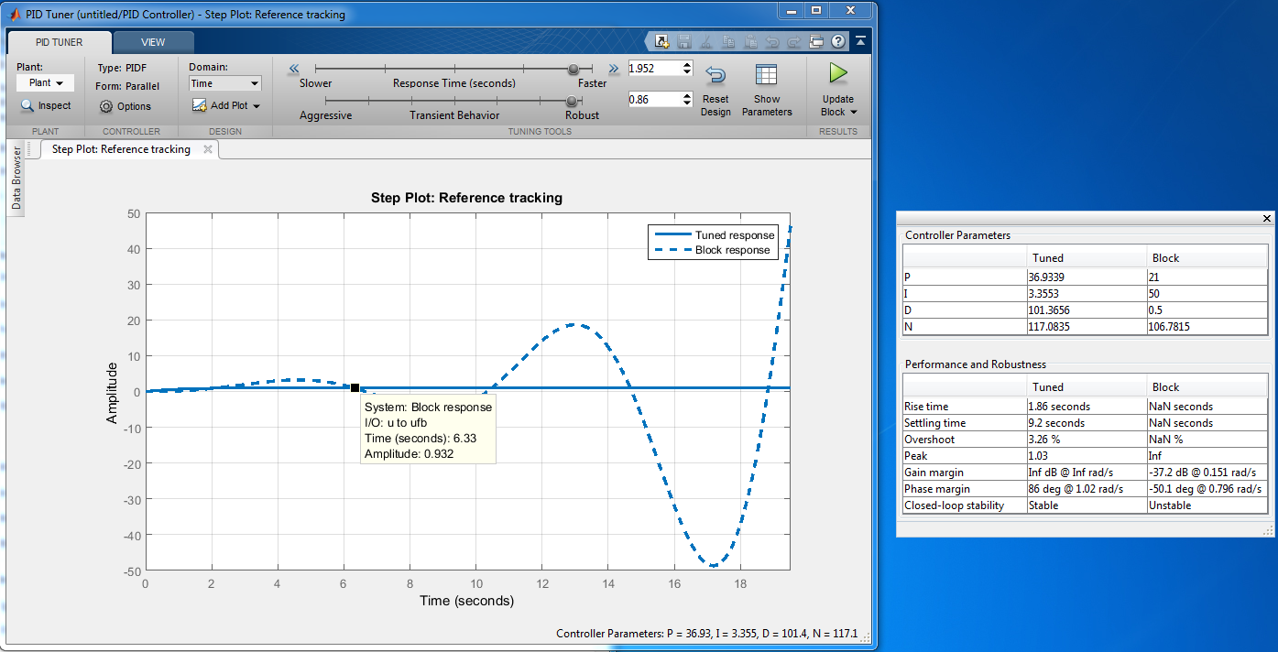

Figure 8: Plot of the Response for Corresponding Controller Gain Values with Tune Response

We used the 5th Control Action for this part which was $K{}_{p}^{} = 10,K{}_{i}^{} = 1, K{}_{d}^{} = 20.$

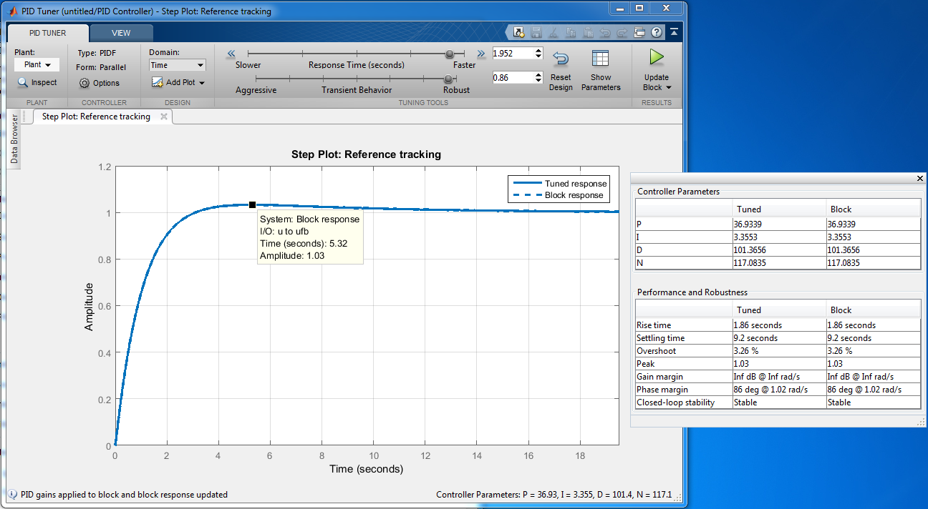

Figure 9: Plot of the Control Action for the Tuned Controller

Above plot shows the control action for the tuned controlled. It meets the requirements of:

* Rise Time less than 2 seconds
* Overshoot less than 5%
* Steady State Error $e{}_{ss}^{}=0$.

**Task C: Unit Step Disturbance**

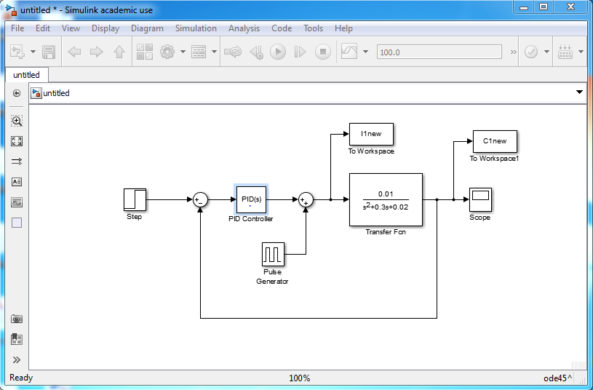

Figure 10: Simulink Model with Unit Step Disturbance

Above is the model with an additional unit-step disturbance on the control input u(t). We used the pulse generator as our disturbance. After looking at the graphs, nothing changed meaning our controller was working and was able to compensate for the pulse generator.

**Conclusion**

For this lab, we analyzed the closed - loop unit step system. We were able to see that this type of system analyst is more efficient than a open loop unit step system because it gave us an output closer to our input. We manually calculated and plotted the system response to various PID gains and saw that when Kp increased, the overshoot time increased. Kd increases the overshoot, Ki decreases the overshoot. We also used MATLAB and the given script in order to find the optimal PID gains. We also were introduced to the concept of unit step disturbance.